A PROJECT REPORT

ON

DANCING MUSICAL FOUNTAIN

Submitted by

In partial fulfillment of the requirements for the award

of

DIPLOMA

IN

ELECTRONICS AND COMMUNICATION ENGINEERING

AT



DEPARTMENT OF ELECTRONICS AND COMMUNICATION ENGINEERING

# GOVERNMENT WOMENS POLYTECHNIC COLLEGE ERNAKULAM

APRIL 2023

GOVERNMENT WOMENS POLYTECHNIC COLLEGE

ERNAKULAM



# A PROJECT REPORT ON

AUTOMATIC WIRE CUTTER AND STRIPPER

SUBMITTED TO:

SHYNA C

GROUP

MEMBERS

1. SREELAKSHMI T.K 20040057 5. ARYA E.S 20040019

1. JEESU M.R. 20040034 6. AKSHARA SOMAN 20040006

1. PRIYA JOY 20040049 7. ATHULYA M.S 20040023

1. ARCHANA P.U. 20040016 8.APARNA ASOKAN 20040013

GOVERNMENT WOMENS POLYTECHNIC

COLLEGE, ERNAKULAM



CERTIFICATE

This is to certify that the report entitled “Dancing Musical Fountain” submitted by Mr. --------------, Reg.No:------------- to the State Board of Technical Education, Kerala in partial fulfillment of therequirements for the award of the Diploma in Electronics And Communication Engineering is a bonafied record of the project work carried out by him under my guidance and supervision. This report in any form has not been submitted to any other University or Institute for any purpose.

Staff in Charge Head of

## Department

Date:

Place:

Internal Examiner

nal Examiner Exter

DECLARATION

I undersigned hereby declare that the project report "DANCING MUSICAL FOUNTAIN" submitted for partial fulfillment of the requirements for the award of Diploma in electronics and communication Engineering of the State Board of Technical Education, Kerala is a bonafide work done by me This submission represents my ideas in my own words and where ideas or words of others have been included; I have adequately and accurately cited and referenced the original sources. I also declare that I have adhered to ethics of academic honesty and integrity and have not misrepresented or fabricated any data or idea or fact or source in my submission. I understand that any violation of the above will be a cause for disciplinary action by the institute or the State Board of Technical Education and can also evoke penal action from the sources which have thus not been properly cited or from whom proper permission has not been obtained. This report has not been previously formed the basis for the award of any degree, diploma or similar title of any other University.

Date: Sign:

Place: Name:

**ABSTRACT**

A musical water fountain, also known as a dancing fountain , is a type of animated fountain are used to day to decorate city parks and squares ; to honor individuals or events that creates an aesthetic design. The musical fountain combines moving jets of water, sound detector, colored lights and recorded music, that controlled by a microcontroller or computer, for dramatic effects. In this paper a mini and low cost musical fountain was designed using Arduino board. Arduino was used to control watervalves and create interesting effects in the fountain, like pulses of water that are timed to be in synchronization with music. A transistor also used as switch to turn the fountain on and off according to the music and the particular LED will light up synchronously.

**INTRODUCTION**

Fountains that are choreographed to music Edit

The earliest musical fountains were played manually by a live operator, who usually controlled pumps or valves and sometimes lights by way of switches on a control panel. Music was almost always live. Later, choreography could be pre-recorded on a punched paper card which was scanned by a computer; and even later, it could be recorded on magnetic tape or, in the most modern shows, on a CD or in an app along with the music. In most automated examples, the choreography is still painstakingly programmed by hand, while some shows are still played live from a control console (sometimes recorded for automatic playback). Recent advances in technology provides for unattended automatic choreography that can rival manual programming.

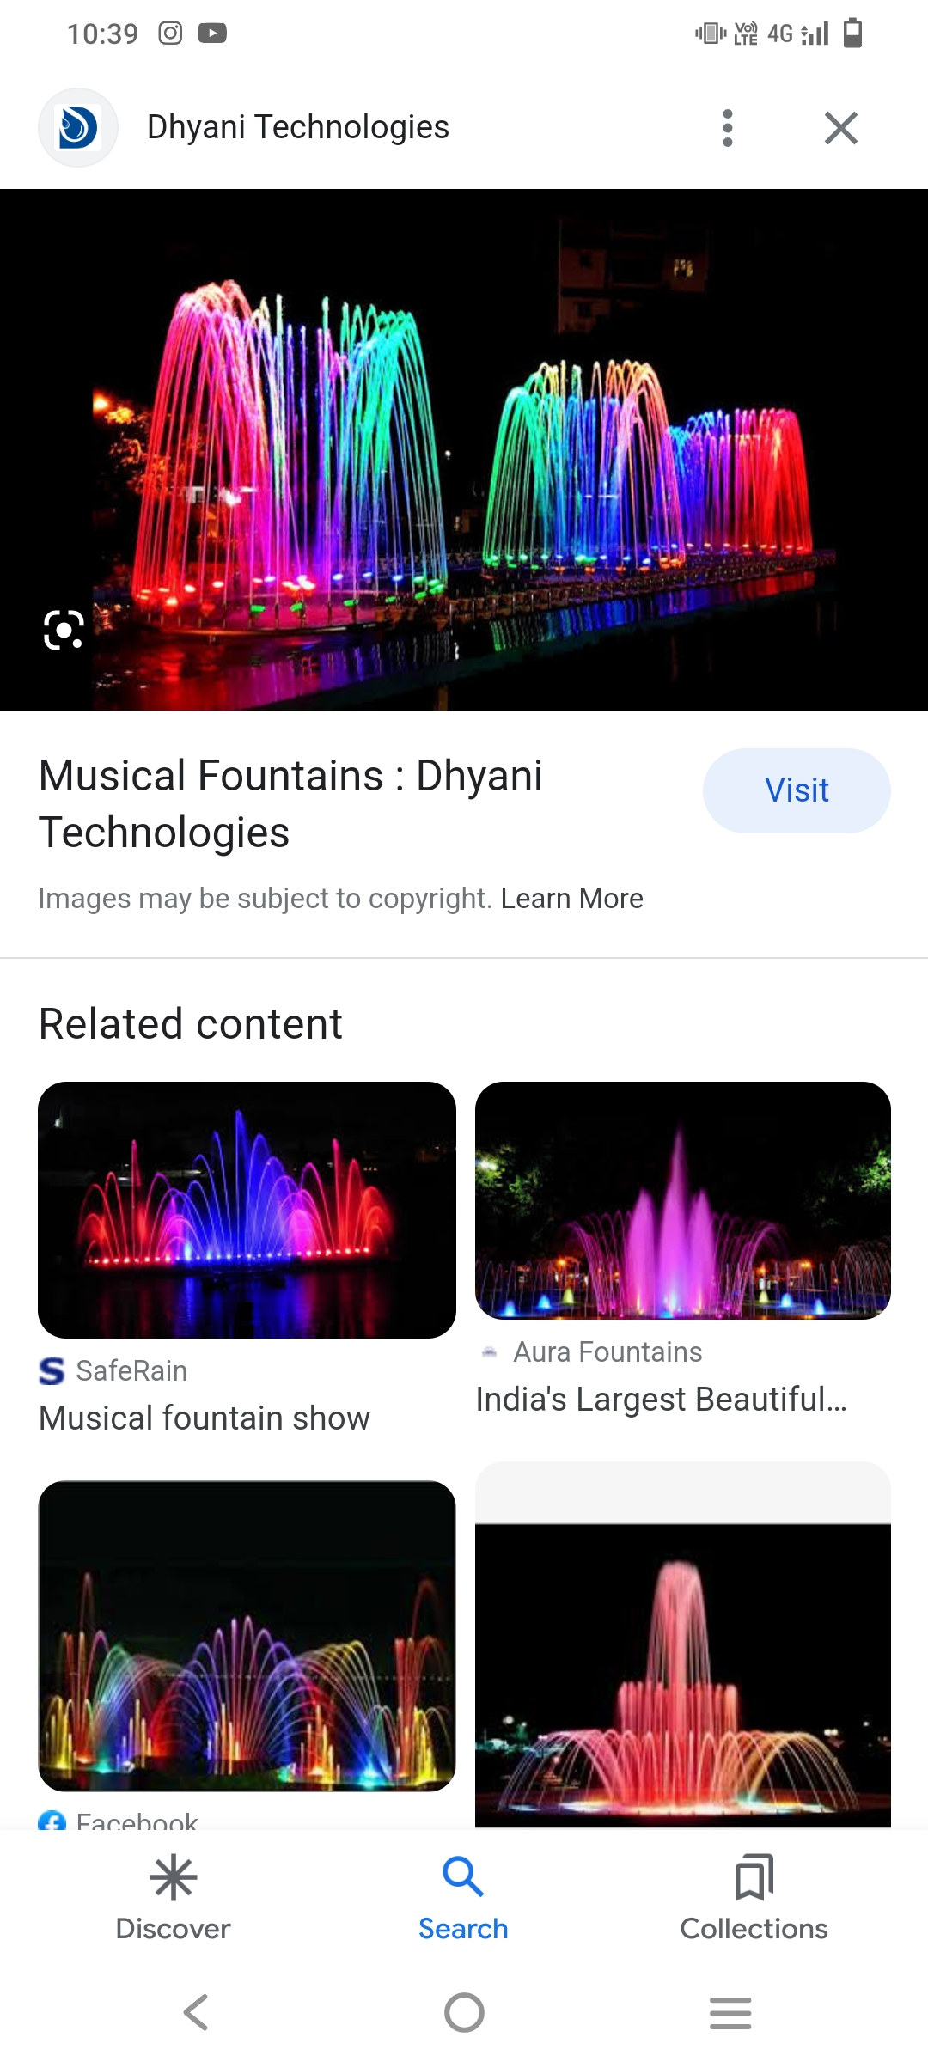

Objective of fountain

Dancing fountains, or musical fountains, provide an engaging feature, which when combined with beautiful music provides an incredibly moving and uplifting entertainment.

The use of fountains as decorative pieces dates back to the Roman era. With modern technology the design of water fountains is only limited by your imagination. The layout design of your fountain system will take inspiration from the architecture where it is going to be placed, and the themes and messages you wish to communicate. Like good architecture, good fountain design can really lift mood, creating a feeling of wellbeing, while entertaining your guests, audience or the general public

As the concept is developed a full visualisation of the concept will be delivered, as both still images and in full animation. This will also help to develop the musical pallet you wish to explore, which might look at original music, classical selections, or using available production music.

A full design of the fountain system will then be developed based on an approved concept. This would also include development of the chosen control system and audio solution. The system design will utilise the best in pumps, LED Lighting, effect nozzles and moving nozzles. The system design will utilise stainless steel or durable plastic as appropriate.

For existing lakes or rivers where the fountain cannot be fixed, floating system will be developed. For saltwater conditions, the design will be adapted based on the conditions and might combine a floating solution with higher grade stainless steel, and sacrificial anodes.

Our objective is to deliver you an amazing fountain system and to provide your audience with fabulous dancing fountains shows, whilst making the process as smooth as possible for you.

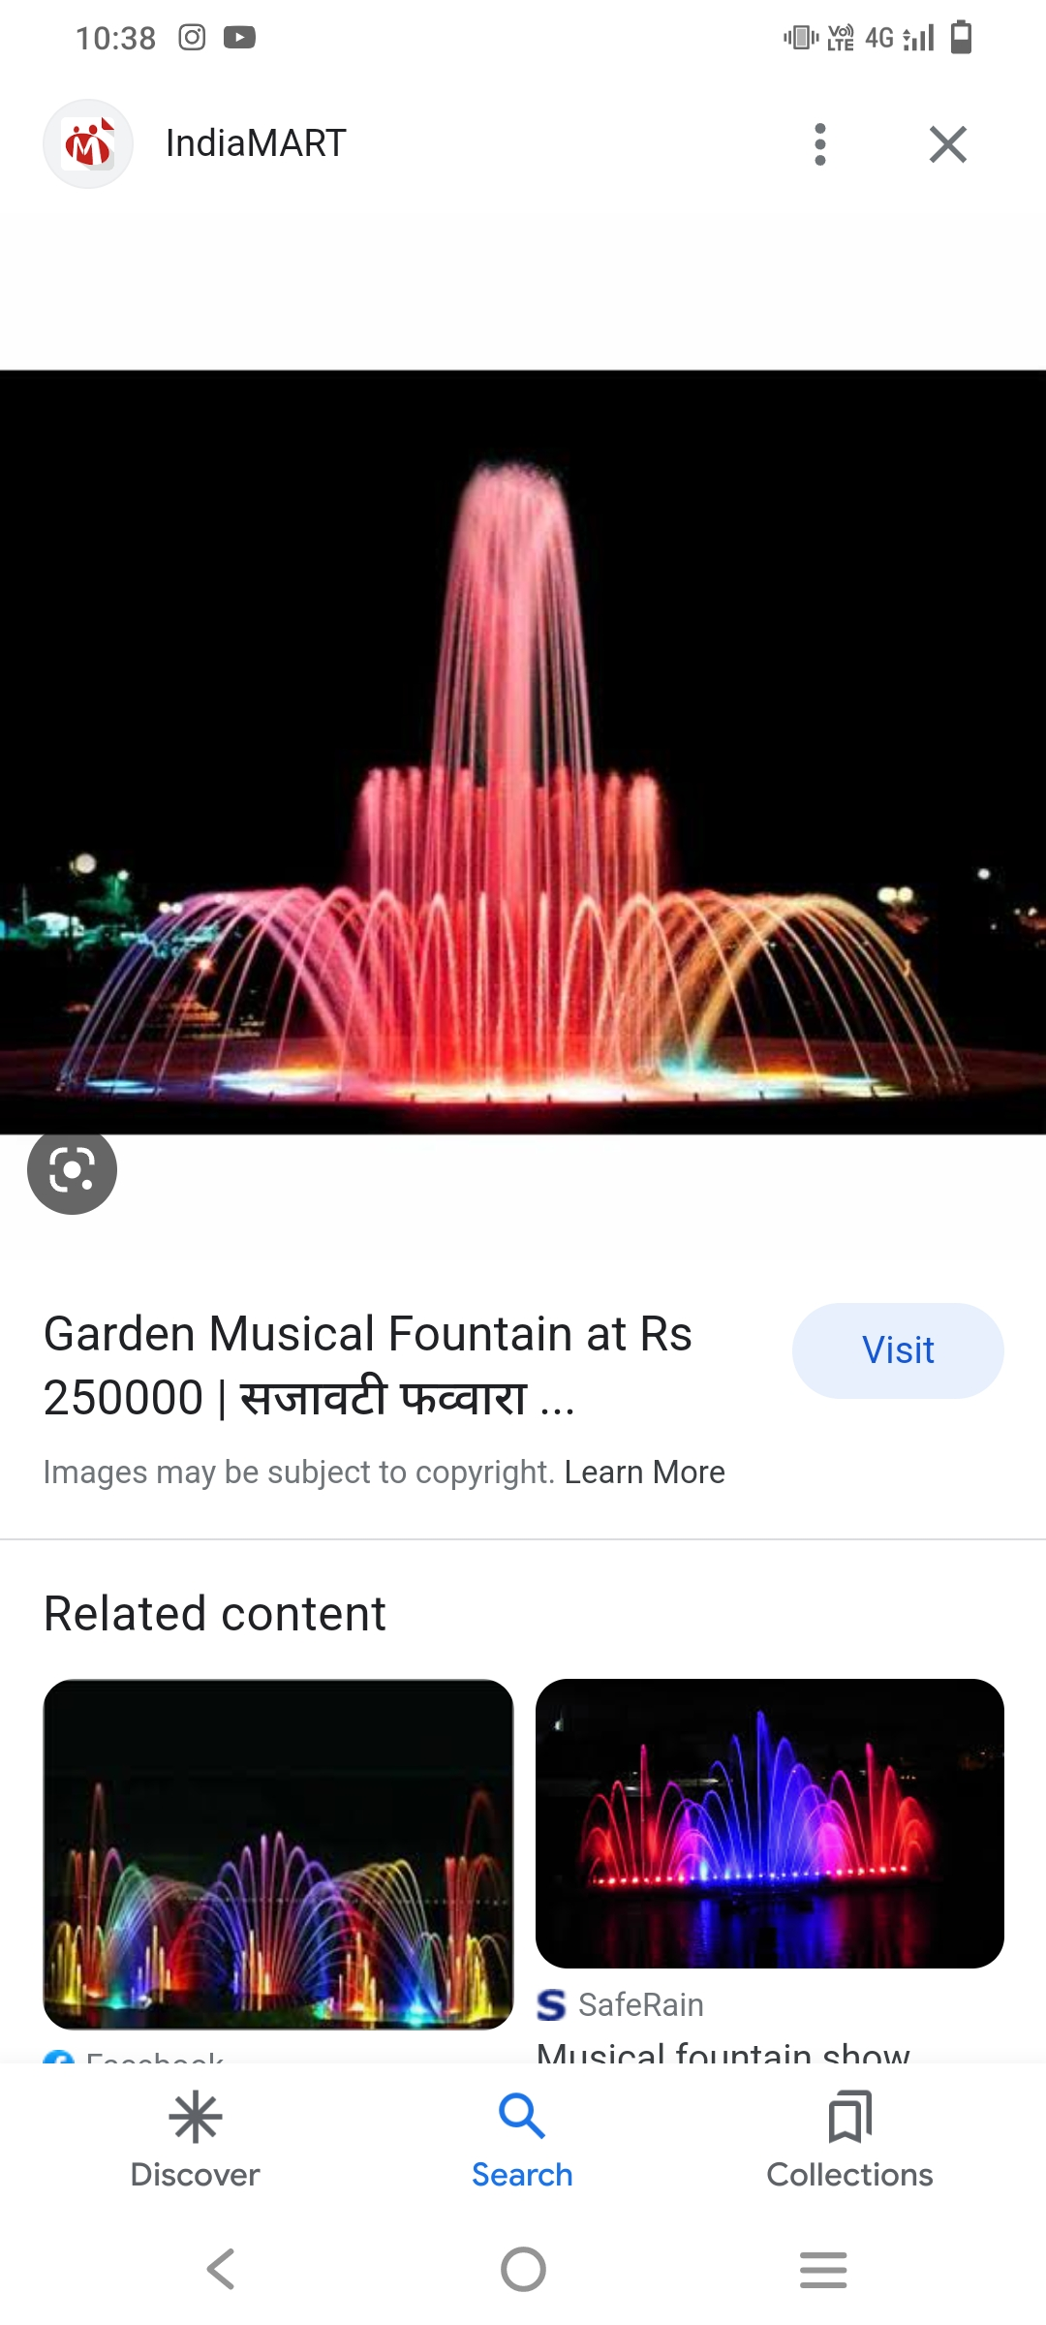

**COMPONENTS USED**

**1.ARDUINO UNO**

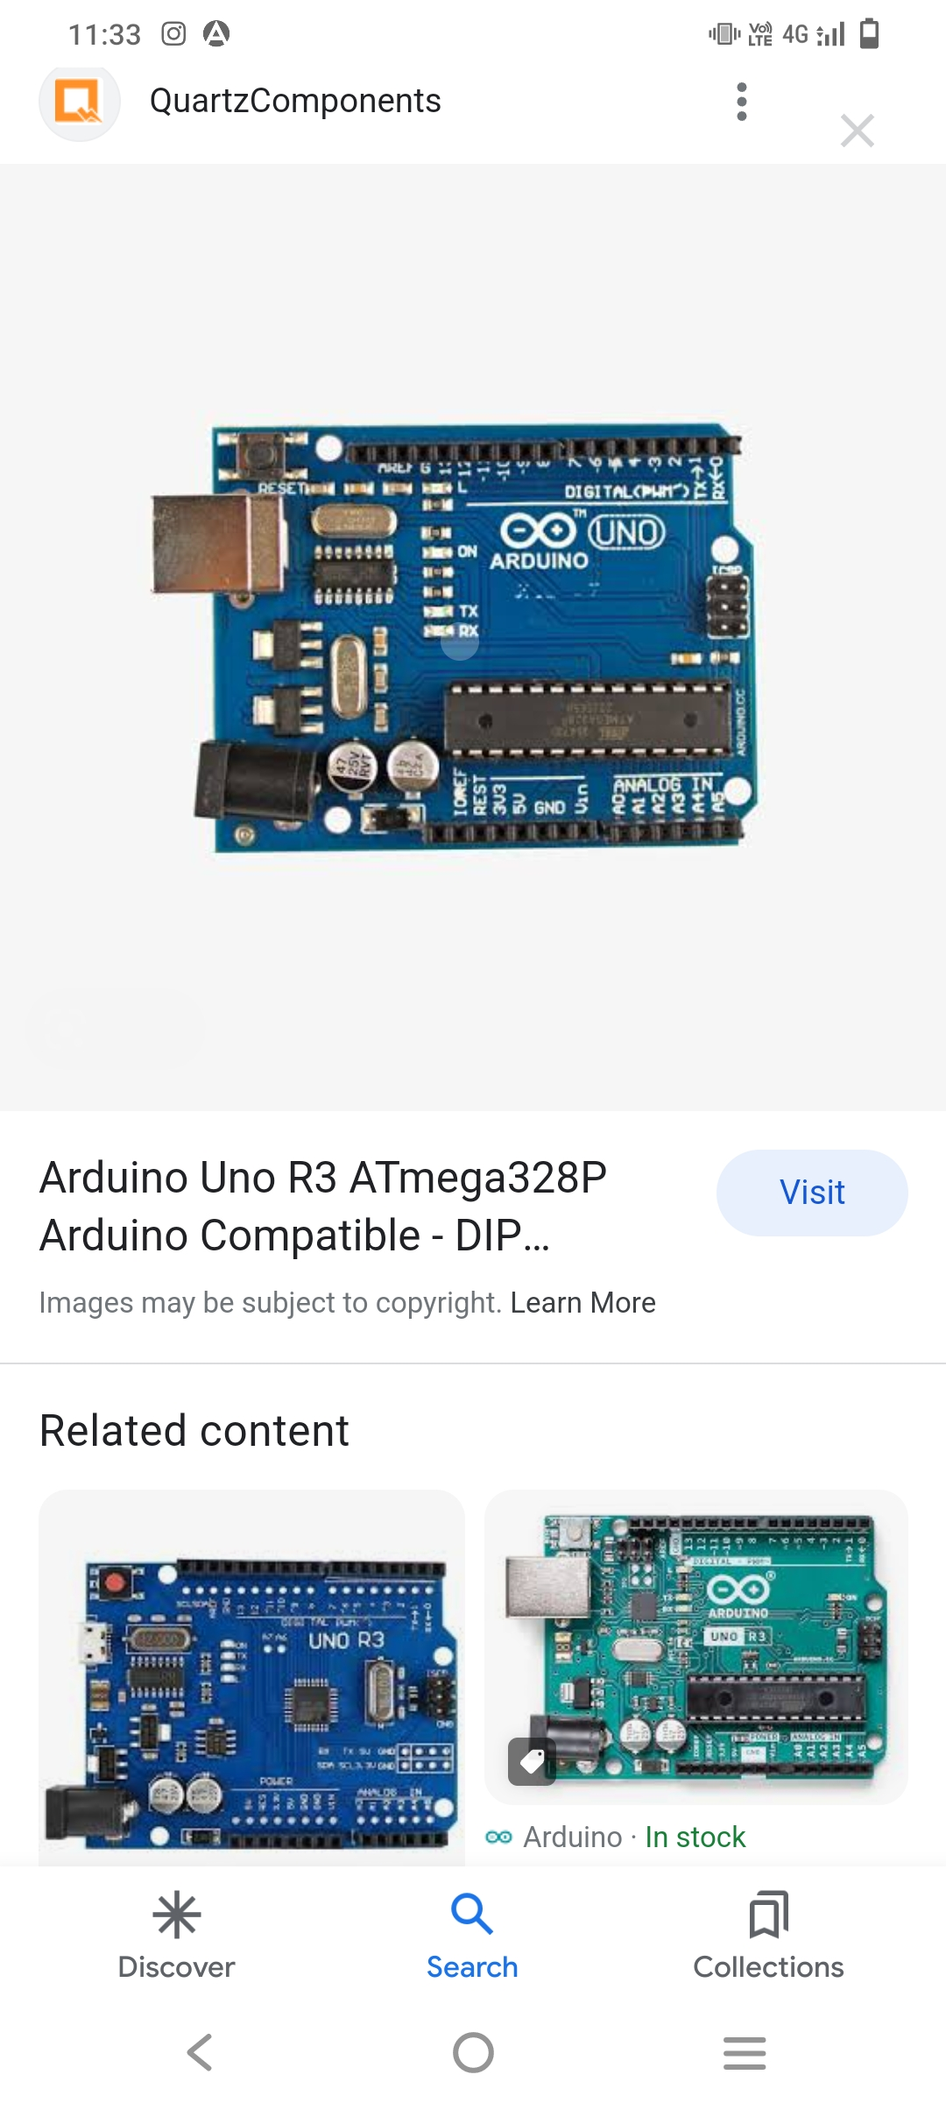

This Arduino Uno is an original microcontroller board from Arduino officials based on the ATmega328P. It has 14 digital input/output pins (of which 6 can be used as PWM outputs), 6 analog inputs, a 16 MHz quartz crystal, a USB connection, a power jack, an ICSP header and a reset button. It contains everything needed to support the microcontroller; simply connect it to a computer with a USB cable or power it with an AC-to-DC adapter or battery to get started.. You can tinker with your UNO without worrying too much about doing something wrong, worst case scenario you can replace the chip for a few dollars and start over again.

“Uno” means one in Italian and was chosen to mark the release of Arduino Software (IDE)1.0.The Uno board and version 1.0 of arduino software (IDE) where the reference versions of arduino, now evolved to newer releases. The original Arduino Uno rev3 board is the first in a series of USB arduino boards and the reference model for the arduino platform; for an extensive list of current, past or outdated boards see the arduino index of boards.

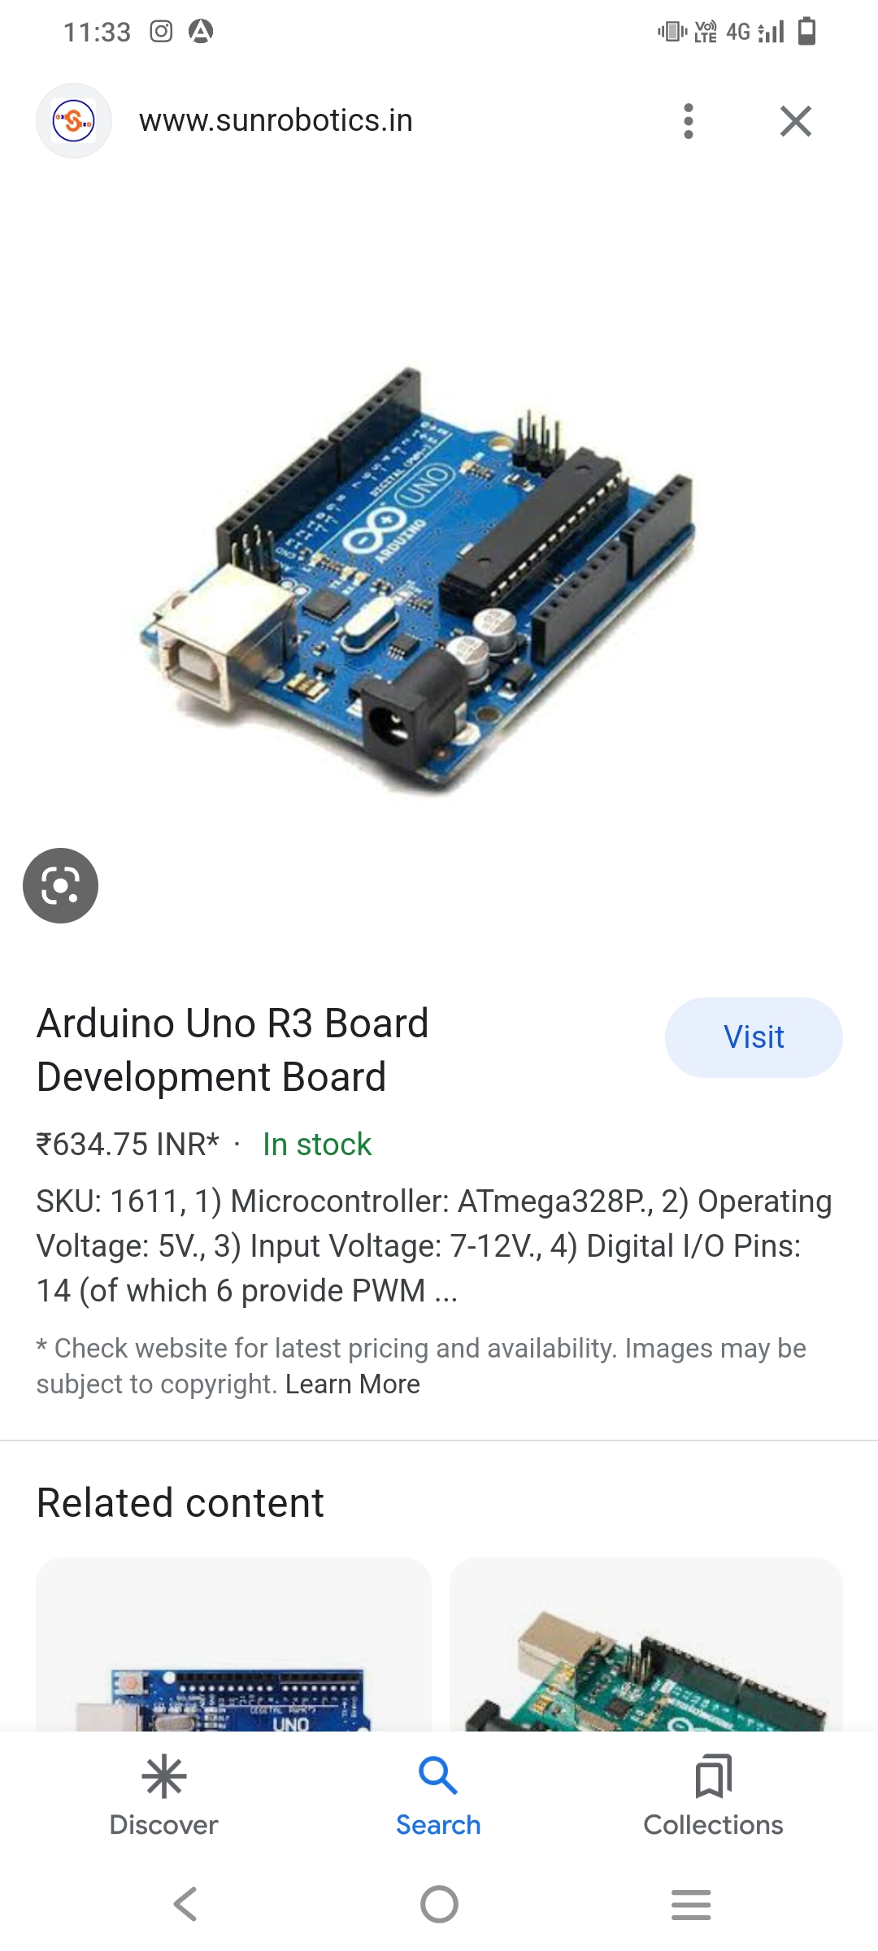

**FEATURES:**

• It is an easy USB interface. This allows interface with USB as this is like a serial device.

• The chip on the board plugs straight into your USB port and supports on your computer as a virtual serial port.

The benefit of this setup is that serial communication is an extremely easy protocol which is time-tested and USB makes connection with modern computers and makes it comfortable.

• It is easy-to-find the microcontroller brain which is the ATmega328 chip

. It has more number of hardware features like timers, external and internal interrupts, PWM pins and multiple sleep modes

• It is an open source design and there is an advantage of being open source is that it has a large community of people using and troubleshooting it.

This makes it easy to help in debugging projects.

• it is very convenient to manage power inside it and it had a feature of built-in voltage regulation. This can also be powered directly off a USB port without any external power. You can correct an external power source of up to 12v and this regulates it to both 5v and 3.3v 14 digital pins and 6 analog pins. This sort of pins allows you to connect hardware to Arduino board externally. These pins are used as a key for extending the computing capability of the Arduino Uno into the real world. Simply plug your electronic devices and sensors into the sockets that correspond to each of these pins and you are good to go.

• This has an ICSP connector for bypassing the USB port and interfacing the Arduino directly as a serial device. This port is necessary to re-boot load your chip if it corruptsand can no longer used to your computer.

• It has a 32 KB of flash memory for storing your code.

• An on-board LED is attached to digital pin 13 to make fast the debugging of code and to make the debug process easy.

• Finally, it has a button to reset the program on the chip.

**2.ARDUINO NANO**

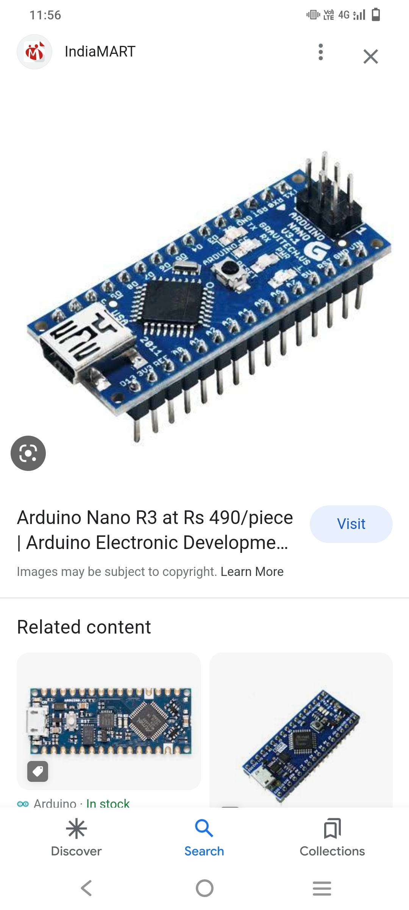

The **Arduino Nano** is a small, complete, and breadboard-friendly board based on the [ATmega328P](https://en.wikipedia.org/wiki/ATmega328) released in 2008. It offers the same connectivity and specs of the [Arduino Uno](https://en.wikipedia.org/wiki/Arduino_Uno) board in a smaller form factor.

The Arduino Nano is equipped with 30 male [I/O](https://en.wikipedia.org/wiki/I/O) headers, in a [DIP-30](https://en.wikipedia.org/wiki/Dual_in-line_package)-like configuration, which can be programmed using the [Arduino](https://en.wikipedia.org/wiki/Arduino) Software [integrated development environment](https://en.wikipedia.org/wiki/Integrated_development_environment) (IDE), which is common to all Arduino boards and running both online and offline. The board can be powered through a [type-B mini-USB](https://en.wikipedia.org/wiki/USB_hardware#Connectors) cable or from a 9 V battery.

The Arduino Nano has a number of facilities for communicating with a computer, another Arduino, or other microcontrollers. The ATmega328 provides UART TTL (5V) serial communication, which is available on digital pins 0 (RX) and 1 (TX).

An FTDI FT232RL on the board channels this serial communication over USB and the FTDI drivers (included with the Arduino firmware) provide a virtual com port to software on the computer. The Arduino software includes a serial monitor which allows simple textual data to be sent to and from the Arduino board. The RX and TX LEDs on the board flash when data is being transmitted via the FTDI chip and the USB connection to the computer (but not for serial communication on pins 0 and 1). A Software Serial library allows for serial communication on any of the Nano's digital pins. The ATmega328 also supports I2C and SPI communication. The Arduino software includes the Wire library to simplify use of the I2C bus.

Technical specifications

[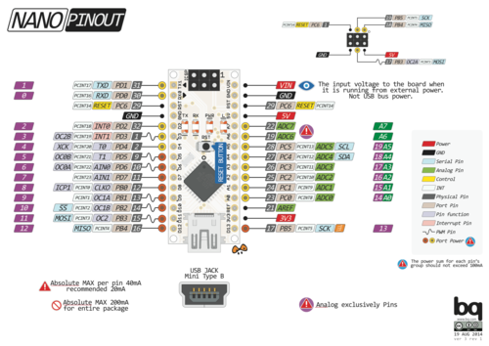](https://en.wikipedia.org/wiki/File:Arduino-nano-pinout.png)

* Operating voltage: 5 volts
* Microcontroller: Microchip ATmega328p
* Input voltage: 5 to 20 volts
* Digital I/O pins: 14 (6 optional PWM outputs)
* Analog input pins: 8
* DC per I/O pin: 40 mA
* DC for 3.3 V pin: 50 mA
* Flash memory: 32 KB, of which 2 KB is used by bootloader
* SRAM: 2 KB
* EEPROM: 1 KB
* Clock speed: 16 MHz
* Length: 45 mm
* Width: 18 mm
* Mass: 7 g
* USB: Mini-USB Type-B
* ICSP Header: Yes
* DC Power Jack: No

**3.SOLENOID VALVE**

Solenoid valves differ in the characteristics of the electric current they use, the strength of the magnetic field they generate, the mechanism they use to regulate the fluid, and the type and characteristics of fluid they control. The mechanism varies from linear action, plunger-type actuators to pivoted-armature actuators and rocker actuators.The valve can use a two-port design to regulate a flow or use a three or more port design to switch flows between ports. Multiple solenoid valves can be placed together on a manifold.

Solenoid valves are the most frequently used control elements in fluidics. Their tasks are to shut off, release, dose, distribute or mix fluids. They are found in many application areas. Solenoids offer fast and safe switching, high-reliability, long service life, good medium compatibility of the materials used, low control power and compact design.

Example core tubes. Non-magnetic core tubes are used to isolate the fluid from the coil. The core tube encloses the plugnut, the core spring, and the core. The coil slips over the core tube; a retaining clip engages the depression near the closed end of the core tube and holds the coil on the core tube.Solenoid valve designs have many variations and challenges.

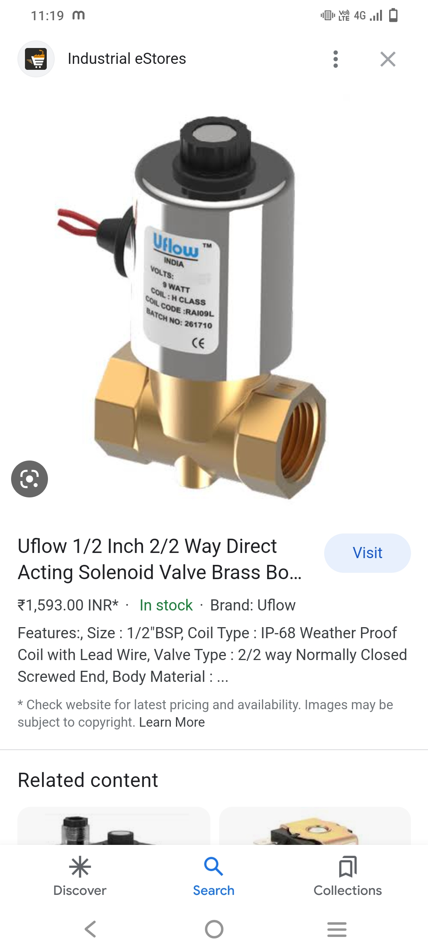

Common components of a solenoid valve

Solenoid subassembly

Retaining clip (a.k.a. coil clip)

Solenoid coil (with magnetic return path)

Core tube (a.k.a. armature tube, plunger tube, solenoid valve tube, sleeve, guide assembly)

Plugnut (a.k.a. fixed core)

Shading coil (a.k.a. shading ring)

Core spring (a.k.a. counter spring)

Core (a.k.a. plunger, armature)

Core tube–bonnet seal

Bonnet (a.k.a. cover)

Bonnet–diaphragm–body seal

Hanger spring

Backup washer

Diaphragm

Bleed hole

Disk

Valve body

Seat

The core or plunger is the magnetic component that moves when the solenoid is energized. The core is coaxial with the solenoid. The core's movement will make or break the seals that control the movement of the fluid. When the coil is not energized, springs will hold the core in its normal position.

The plugnut is also coaxial.

The core tube contains and guides the core. It also retains the plugnut and may seal the fluid. To optimize the movement of the core, the core tube needs to be nonmagnetic. If the core tube were magnetic, then it would offer a shunt path for the field lines. In some designs, the core tube is an enclosed metal shell produced by deep drawing. Such a design simplifies the sealing problems because the fluid cannot escape from the enclosure, but the design also increases the magnetic path resistance because the magnetic path must traverse the thickness of the core tube twice: once near the plugnut and once near the core. In some other designs, the core tube is not closed but rather an open tube that slips over one end of the plugnut. To retain the plugnut, the tube might be crimped to the plugnut. An O-ring seal between the tube and the plugnut will prevent the fluid from escaping.

The solenoid coil consists of many turns of copper wire that surround the core tube and induce the movement of the core. The coil is often encapsulated in epoxy. The coil also has an iron frame that provides a low magnetic path resistance.

**ADAPTER**

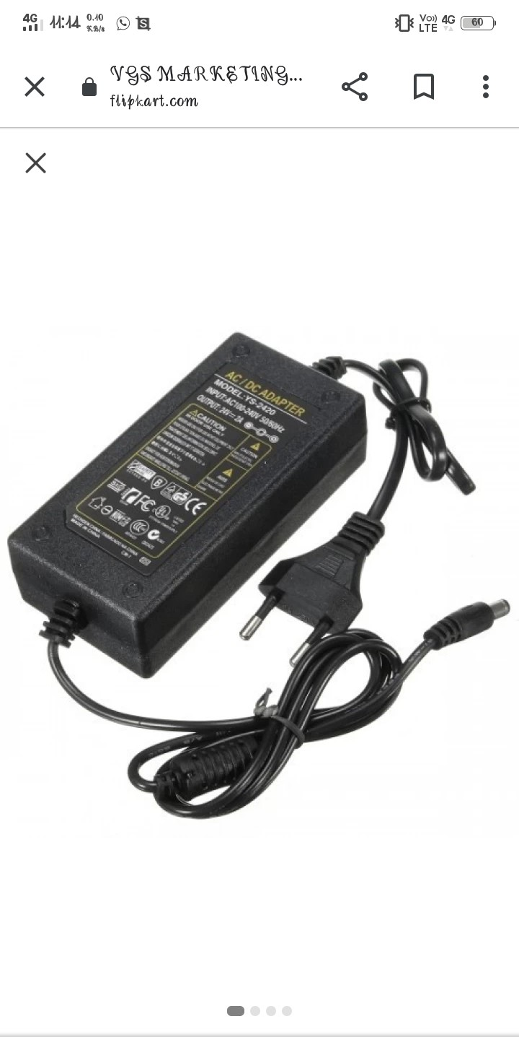

The 24V 2A power adapter is generally applicable to: advertising device, display, audio, communications, IT, lighting, electronic instruments, amplifiers, printers, LCD TV, GPS navigation, digital photo frame, industrial products etc.

**RELAY**

Relay is one kind of electro-mechanical component that functions as a switch. The relay coil is energized by DC so that contact switches can be opened or closed. A single channel 5V relay module generally includes a coil, and two contacts like normally open (NO) and normally closed (NC). first we have to know what is relay and its pin configuration.

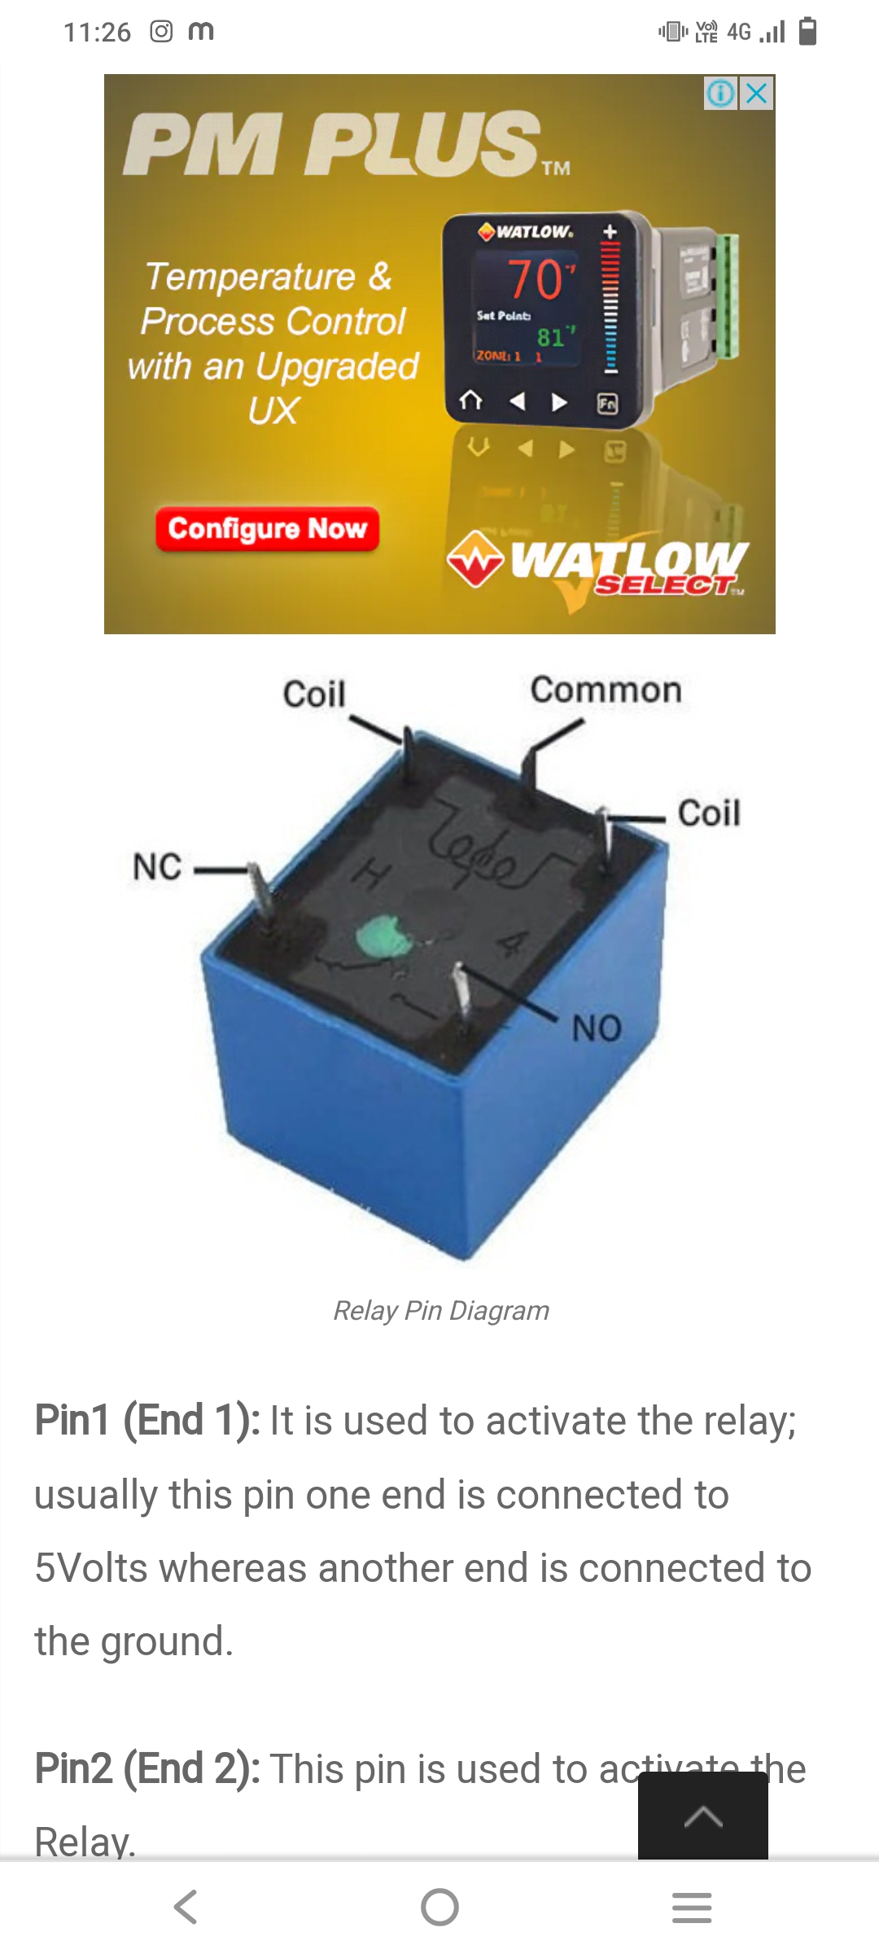

A 5v relay is an automatic switch that is commonly used in an automatic control circuit and to control a high-current using a low-current signal. The input voltage of the relay signal ranges from 0 to 5V.

5V Relay Pin Configuration

.Pin1 (End 1): It is used to activate the relay; usually this pin one end is connected to 5Volts whereas another end is connected to the ground.

Pin2 (End 2): This pin is used to activate the Relay.

Pin3 (Common (COM)): This pin is connected to the main terminal of the Load to make it active.

Pin4 (Normally Closed (NC)): This second terminal of the load is connected to either NC/ NO pins. If this pin is connected to the load then it will be ON before the switch.

Pin5 (Normally Open (NO)): If the second terminal of the load is allied to the NO pin, then the load will be turned off before the switch.

Features

The features of the 5V relay include the following.

Normal Voltage is 5V DC

Normal Current is 70mA

AC load current Max is 10A at 250VAC or 125V AC

DC load current Max is 10A at 30V DC or 28V DC

It includes 5-pins & designed with plastic material

Operating time is 10msec

Release time is 5msec

Maximum switching is 300 operating per minute

**ADAPTER**

DC 5V/2A, means that the input voltage, to recharge the battery is 5 volts of direct current. 2A Is the amount of amperage that is suggested to recharge the battery. 5V/2A charger, which could charge a phone up to 40% faster than conventional 5V, 1A chargers

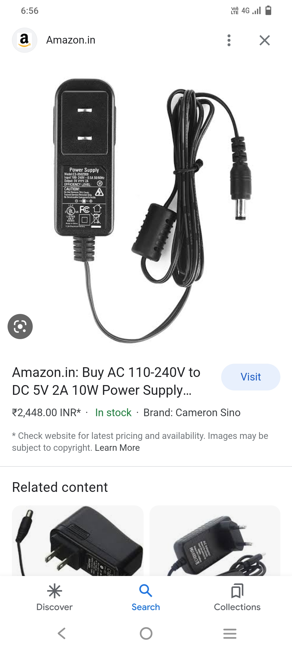

**LED**

A light-emitting diode (LED) is a semiconductor device that emits light when current flows through it. Electrons in the semiconductor recombine with electron holes, releasing energy in the form of photons. The color of the light (corresponding to the energy of the photons) is determined by the energy required for electrons to cross the band gap of the semiconductor. White light is obtained by using multiple semiconductors or a layer of light-emitting phosphor on the semiconductor device.

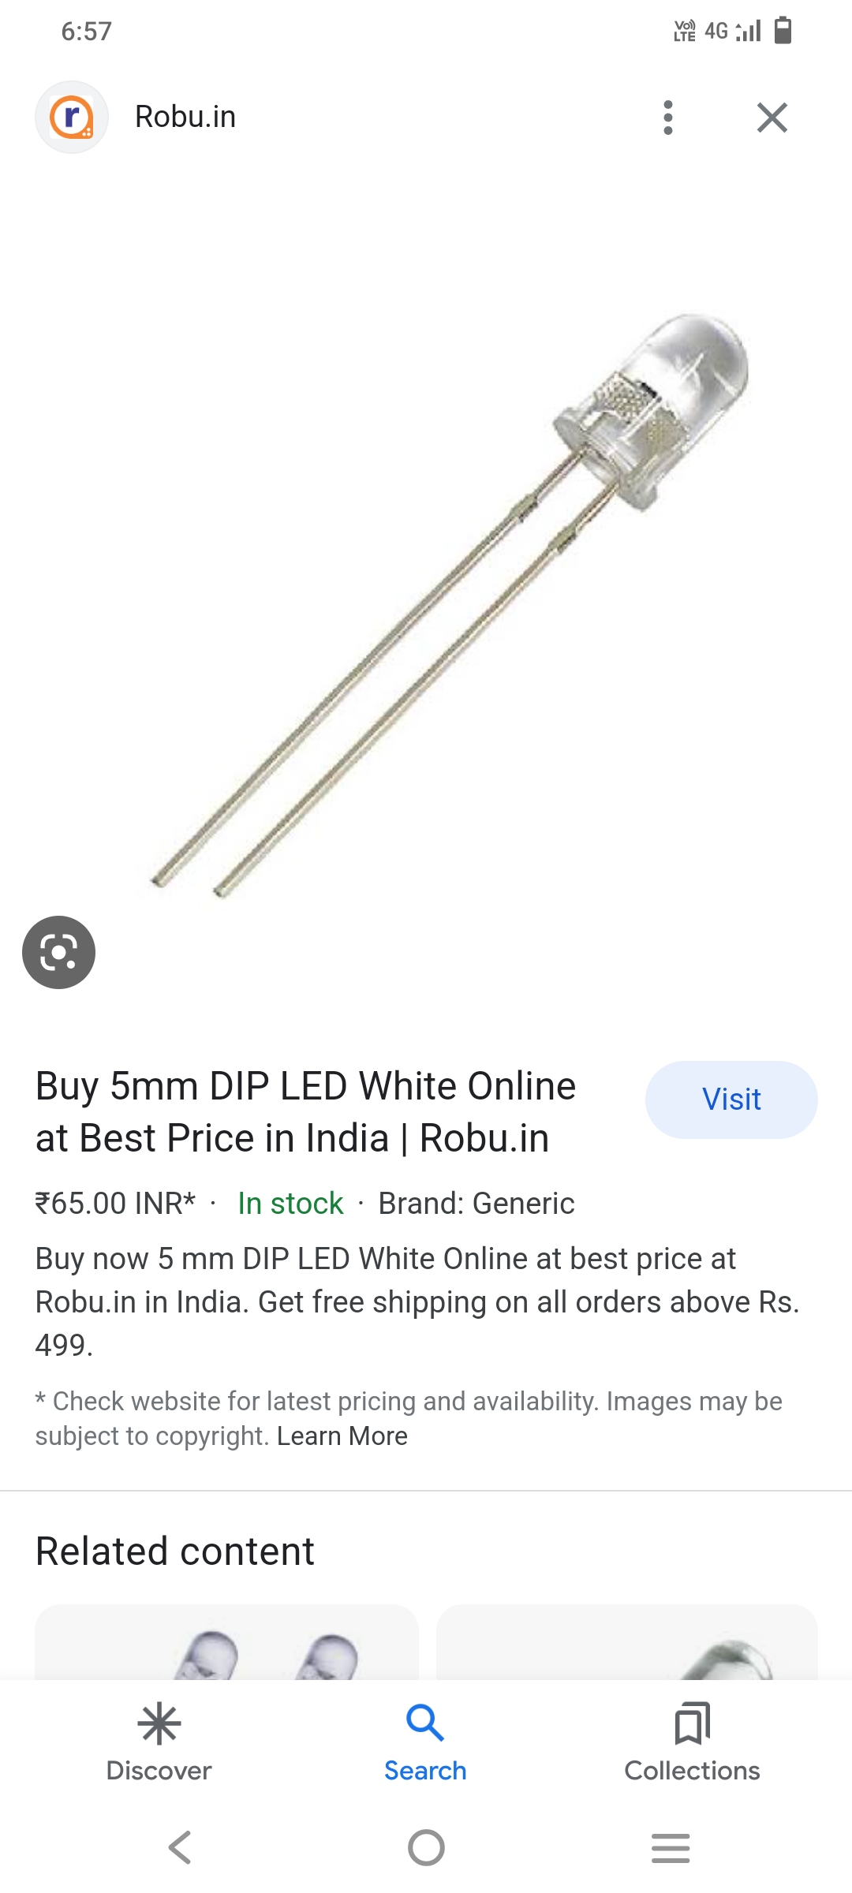

**CIRCUIT DIAGRAM**

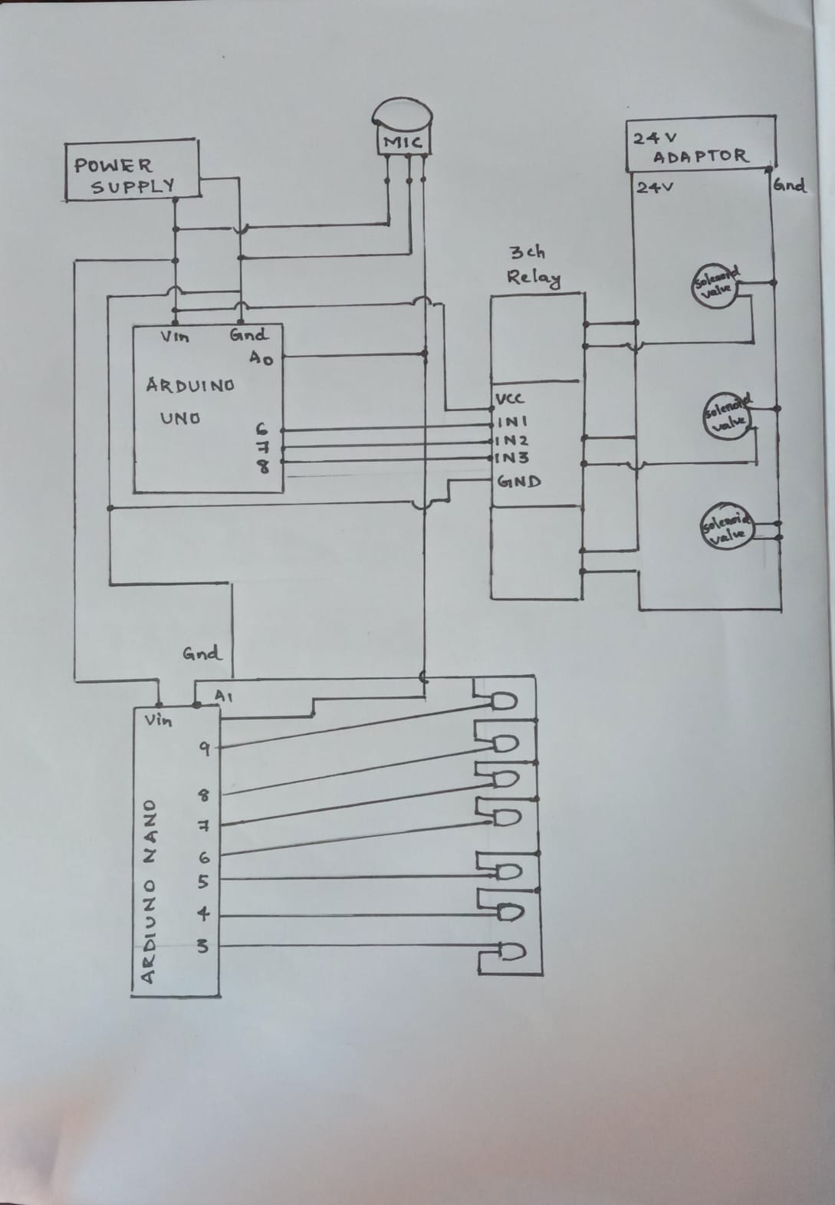

**WORKING**

An input signal taken from sources such as smart phone, laptop etc by the microphone is given to Arduino UNO and Arduino Nano.The Arduino Uno is used to turn on and off the solenoid valve using relay. Arduino Nano is used for blinking the LED's . The signal which is given to the analogue pin A1 of Arduino Nano which it ranges from 0 - 1023 (10 bits). The signal thus received is divided into sections like 600 - 700, 700 - 800 etc. for blinking the LED's. The led's blink according to the sound signal which is received from the microphone.

The sound signal which is given to the Arduino Uno is used to control the solenoid valve using relay. Here the signal is divided into bands of different values in which the solenoid valve can recognize. For example if the band ranges is in between 600 - 800 , the relay switches and the valve which corresponds to the relay will turn on and remaining will be on a stable condition. Two valves become open if we switches two relays simultaneously by giving a range of 200 - 800 . It is designed depending on different kind of combinations.

**SOFTWARE**

PROGRAM FOR RELAY

#define MIC A1

#define R2 2

#define R1 3

#define R0 4

int Value;

void setup() {

Serial.begin(9600);

pinMode(R2, OUTPUT);

pinMode(R1, OUTPUT);

pinMode(R0, OUTPUT);

}

void Solenoid_valve() {

if (Value >= 600 && Value < 685) {

digitalWrite(R0, 0);

delay(200);

digitalWrite(R1, 0);

delay(100);

digitalWrite(R2, 1);

delay(50);

}

if (Value >= 685 && Value < 750)

{

digitalWrite(R2, 1);

digitalWrite(R0, 0);

delay(50);

digitalWrite(R1,

0);

delay(100);

}

if (Value >= 750 && Value < 845) {

digitalWrite(R0, 0);

delay(80);

digitalWrite(R1, 1);

delay(150);

digitalWrite(R2, 0);

delay(100);

}

if (Value >= 845 && Value < 945)

{

digitalWrite(R0, 0);

delay(80);

digitalWrite(R1, 0);

delay(150);

digitalWrite(R2, 1);

delay(40);

}

if (Value >= 945 && Value <

1000) {

digitalWrite(R0, 0);

delay(180);

digitalWrite(R1, 1);

digitalWrite(R1, 0);

delay(250);

digitalWrite(R2, 0);

delay(300);

digitalWrite(R2, 1);

}

if (Value >= 1000 && Value < 1745) {

digitalWrite(R0, 0);

delay(180);

digitalWrite(R1, 0);

delay(250);

digitalWrite(R0, 1);

digitalWrite(R1, 1);

digitalWrite(R2, 0);

delay(300);

}

}

void loop() {

Value = analogRead(A1);

Serial.println(Value);

Solenoid_valve();

}

PROGRAM FOR LED

#define MIC A0

//#define KTM D2

int Value;

void setup() {

Serial.begin(9600);

pinMode(13,OUTPUT);

pinMode(12,OUTPUT);

pinMode(11,OUTPUT);

pinMode(10,OUTPUT);

pinMode(9,OUTPUT);

pinMode(8,OUTPUT);

pinMode(7,OUTPUT);

pinMode(6,OUTPUT);

pinMode(5,OUTPUT);

pinMode(4,OUTPUT);

pinMode(3,OUTPUT);

pinMode(2,OUTPUT);

pinMode(1,OUTPUT);

pinMode(0,OUTPUT);

digitalWrite(3,HIGH);digitalWrite(1,HIGH);digitalWrite(0,HIGH);digitalWrite(13,HIGH);

digitalWrite(4,HIGH); digitalWrite(5,HIGH); digitalWrite(6,HIGH); digitalWrite(7,HIGH);

digitalWrite(8,HIGH); digitalWrite(9,HIGH); digitalWrite(10,HIGH);

digitalWrite(11,HIGH); digitalWrite(12,HIGH); digitalWrite(2,HIGH); delay(6000);

}

void loop() {

Value = analogRead(A1);

Serial.println(Value);

if (Value

>= 600 && Value < 680) {

digitalWrite(2,

HIGH);digitalWrite(13,0);digitalWrite(0,0);digitalWrite(1,0);

digitalWrite(3,

0);digitalWrite(4, 0); digitalWrite(12, 0); digitalWrite(11, 0); digitalWrite(10, 0);

digitalWrite(9, 0); digitalWrite(8, 0); digitalWrite(7, 0); digitalWrite(6, 0); digitalWrite(5,

0);

}

if (Value >= 640 && Value < 695) {

digitalWrite(12,

HIGH);digitalWrite(13,0);digitalWrite(0,0);digitalWrite(1,0);

digitalWrite(3,

0);digitalWrite(4, 0); digitalWrite(2, 0); digitalWrite(11, 0); digitalWrite(10, 0);

digitalWrite(9, 0); digitalWrite(8, 0); digitalWrite(7, 0); digitalWrite(6, 0); digitalWrite(5,

0);

}

if (Value >= 685 && Value < 710) {

digitalWrite(11,

HIGH);digitalWrite(13,0);digitalWrite(0,0);digitalWrite(1,0);

digitalWrite(3,

0);digitalWrite(4, 0); digitalWrite(12, 0); digitalWrite(2, 0); digitalWrite(10, 0);

digitalWrite(9, 0); digitalWrite(8, 0); digitalWrite(7, 0); digitalWrite(6, 0); digitalWrite(5,

0);

}

if (Value >= 685 && Value < 750) {

digitalWrite(3,

HIGH);digitalWrite(13,0);digitalWrite(0,0);digitalWrite(1,0);

digitalWrite(11,

0);digitalWrite(4, 0); digitalWrite(12, 0); digitalWrite(2, 0); digitalWrite(10, 0);

digitalWrite(9, 0); digitalWrite(8, 0); digitalWrite(7, 0); digitalWrite(6, 0); digitalWrite(5,

0);

}

if (Value >= 720 && Value < 775) {

digitalWrite(10,

HIGH);digitalWrite(13,0);digitalWrite(0,0);digitalWrite(1,0);

digitalWrite(3,

0);digitalWrite(4, 0); digitalWrite(12, 0); digitalWrite(11, 0); digitalWrite(2, 0);

digitalWrite(9, 0); digitalWrite(8, 0); digitalWrite(7, 0); digitalWrite(6, 0); digitalWrite(5,

0);

}

if (Value >= 760 && Value < 810) {

digitalWrite(9,

HIGH);digitalWrite(13,0);digitalWrite(0,0);digitalWrite(1,0);

digitalWrite(3, 0);

digitalWrite(4, 0); digitalWrite(12, 0); digitalWrite(11, 0); digitalWrite(10, 0);

digitalWrite(2, 0); digitalWrite(8, 0); digitalWrite(7, 0); digitalWrite(6, 0); digitalWrite(5,

0);

}

if (Value >= 800 && Value < 845) {

digitalWrite(8,

HIGH);digitalWrite(13,1);digitalWrite(0,1);digitalWrite(1,1);

digitalWrite(3,

0);digitalWrite(4, 0); digitalWrite(12, 0); digitalWrite(11, 0); digitalWrite(10, 0);

digitalWrite(9, 0); digitalWrite(2, 0); digitalWrite(7, 0); digitalWrite(6, 0); digitalWrite(5,

0);

}

if (Value >= 840 && Value < 900) {

digitalWrite(7,

HIGH);digitalWrite(13,0);digitalWrite(0,0);digitalWrite(1,0);

digitalWrite(3,

0);digitalWrite(4, 0); digitalWrite(12, 0); digitalWrite(11, 0); digitalWrite(10, 0);

digitalWrite(9, 0); digitalWrite(8, 0); digitalWrite(2, 0); digitalWrite(6, 0); digitalWrite(5,

0);

}

if (Value >= 900 && Value < 965) {

digitalWrite(6,

HIGH);digitalWrite(13,0);digitalWrite(0,0);digitalWrite(1,0);

digitalWrite(3, 0);

digitalWrite(4, 0); digitalWrite(12, 0); digitalWrite(11, 0); digitalWrite(10, 0);

digitalWrite(9, 0); digitalWrite(8, 0); digitalWrite(7, 0); digitalWrite(2, 0); digitalWrite(5,

0);

}

if (Value >= 960 && Value < 1100) {

digitalWrite(5,

HIGH);digitalWrite(13,0);digitalWrite(0,0);digitalWrite(1,0);

digitalWrite(3,

0);digitalWrite(4, 0); digitalWrite(12, 0); digitalWrite(11, 0); digitalWrite(10, 0);

digitalWrite(9, 0); digitalWrite(8, 0); digitalWrite(7, 0); digitalWrite(6, 0); digitalWrite(2,

0);

}

if (Value >= 1000 && Value < 1700) {

digitalWrite(4,

HIGH);digitalWrite(13,1);digitalWrite(0,1);digitalWrite(1,1);

digitalWrite(3, 0);

digitalWrite(5, 0); digitalWrite(12, 0); digitalWrite(11, 0); digitalWrite(10, 0);

digitalWrite(9, 0); digitalWrite(8, 0); digitalWrite(7, 0); digitalWrite(6, 0); digitalWrite(2,

0);

}

} Powered by

**BUDGET**

B

|  |  |  |  |  |
| --- | --- | --- | --- | --- |
| Item | Description | Unit Cost(s)+Taxes | Quantity | Item total cost(s) |
| 1. | ARDUINO UNO | 650 | 1 | 650 |
| 2. | NEMA 17 STEPPER MOTOR | 300 | 2 | 300 |
| 3. | 6*4 DOT PCB | 40 | 1 | 40 |
| 4. | A4988 STEPPER MOTOR CONTROLLER | 200 | 2 | 400 |
| 5. | MG 90 SERVO MOTOR | 300 | 1 | 300 |
| 6. | DP 12V 5AMP POWER SUPPLY | 450 | 1 | 450 |
| 7. | CON 40 PIN STRIP WIRE | 10 | 3 | 30 |
| 8. | 10GM LEAD SUPREME | 20 | 1 | 20 |
| 9. | 150BS WIRE STRIPPER | 150 | 1 | 150 |
| 10. | ARDUINO CNC SHIELD | 700 | 1 | 700 |
| 11. | 1602 LCD DISPLAY | 250 | 1 | 250 |
| 12. | 12C MODULE FOR DISPLAY | 150 | 1 | 150 |
| 13. | BUTTON SWITCH | 5 | 3 | 15 |
| 14. | ARDUINO NANO | 650 | 1 | 650 |
| TOTAL | |  | | 4105 |

**REFFERENCE**

1. Keresztes, Gyula (1998). Marosvásárhely régi épületei. Marosvásárhely: Difprescar. pp. 72–74. ISBN 9739866905.

2. "Denver's Prismatic Fountain Will Again Delight Thousands". Denver Municipal Facts. The City of Denver. 1 (14). May 22, 1909.

3. "City Park fountain shows debut Friday". The Denver Post. May 21, 2009. Retrieved April 2, 2021.

4. "Joy back on maidan... bigger & better". www.telegraphindia.com. October 9, 2012. Retrieved April 2, 2021.

5. "Fountain of Joy to spring back to life". The Times of India. October 6, 2012. Retrieved April 2, 2021.

6. "High One Resort South Korea - Gangwon-do". Archived from the original on November 23, 2015. Retrieved November 9, 2015.

7. "Water show : Aquatic Show, water special effects and international water show".

8. "Roshen Fountain in Vinnitsa was opened! :: Confectionery Corporation ROSHEN". roshen.com. Archived from the original on July 10, 2015. Retrieved October 25, 2015

**CONCLUSION**

In this project, a mini and cost effective musical water fountain had designed. Simple components with Arduino were used to build the design. It gave an accurate result such that it worked with any type of music and LEDs gave the project more beautiful effects.

The use of the relay as a switch has made fastest response and the control of valves was very effective**.** This project can be used to decorate houses and offices or it can be built with larger numbers of valves with the same principles so that it can be used in shopping centers